**CS342 – Operating Systems Lab**

**Assignment-4**

Tarusi Mittal 1901CS65

**1. Write a program in C, which takes n, as an user input, and create n number of zombie processes. Show that the created processes are zombie processes (ADD SCREENSHOT)**

Ans:

Compilation: gcc q1.c -o q1

Syntax: ./q1

Here the number n is a user fed input and not the command line argument

Therefore you should press enter after ./q1

{the number n }

Examples of Execution:

Input: gcc q1.c -o q1

./q1

Initial Screenshot of execution

Enter the number n: 4

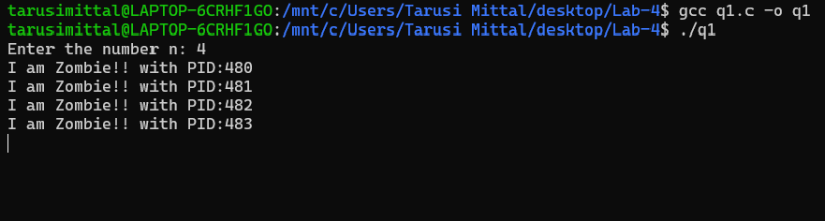

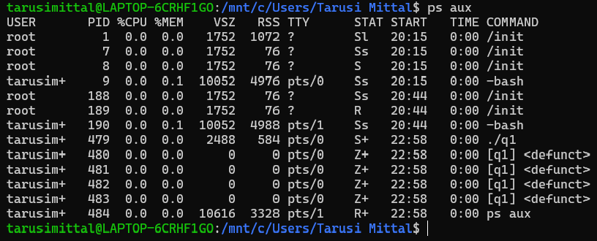

Zombie processes

Parent process

Terminal after 20 Seconds

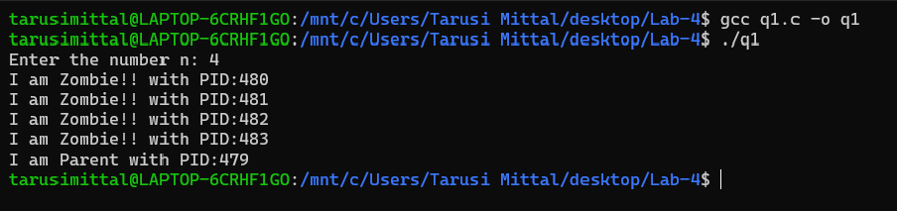

**2. Write a program in C, which takes n, as an user input, and create n number of orphan processes.**

Ans:

Compilation: gcc q2.c -o q2

Syntax: ./q2

Here the number n is a user fed input and not the command line argument

Therefore you should press enter after ./q2

{the number n }

Examples of Execution:

Input: gcc q2.c -o q2

./q2

Initial Screenshot of execution

Enter the number n: 5

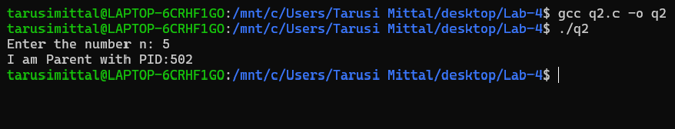

P.T.O

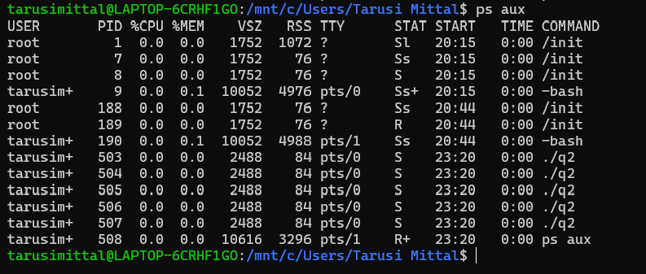

Orphan processes

The parent process is not there as it is already completed

Terminal after 20 seconds:

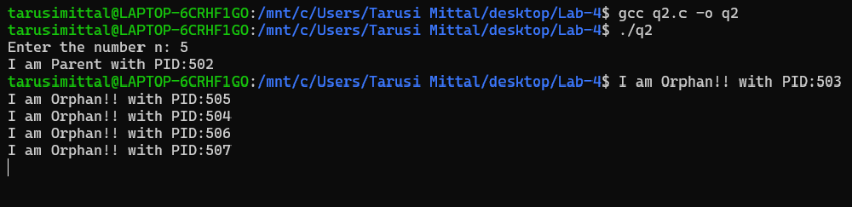

Here we can see that the parent process was first completed and after that the command line reappears for taking inputs and commands and after 20 seconds( the time for the child process to sleep) the child processes which were running in the background gets completed and are printed.

P.T.O

**3.Write a program, which will-**

**- Take a user input N**

**- Make 2 child processes.**

**- one child process should generate first N LUCAS sequence (**[**https://en.wikipedia.org/wiki/Lucas_number).**](https://en.wikipedia.org/wiki/Lucas_number).%20)

**- The 2nd child process should only print the LUCAS sequence (NOT GENERATE) (USE FILE OR SOME OTHER METHOD TO SHARE)**

Ans:

Compilation: gcc q3.c -o q3

Syntax: ./q3

Here the number n is a user fed input and not the command line argument

Therefore you should press enter after ./q3

{the number n }

Examples of Execution:

Input: gcc q3.c -o q3

./q3

Enter the number n: 10

Result:

I am a process with PID: 515 for generating the Lucas Sequence.

I am a process with PID: 516 for printing the Lucas Sequence.

2 1 3 4 7 11 18 29 47 76

For other inputs and results see screenshot attached:

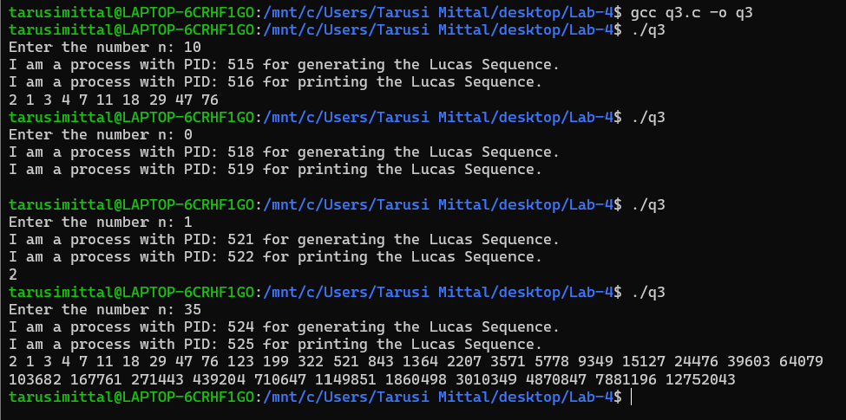

**4. Write a program which will-**

**- Make 3 threads:**

**- One will copy the source program to another file f2.**

**- second will print contents of f2.**

**- Third will delete the file f2.**

Ans:

Compilation: gcc q4.c -o q4

Syntax: ./q4 {name of file 1} {name of file 2 }

Examples of Execution:

Input: gcc q4.c -o q4

./q4 file1.txt file2.txt

Result:

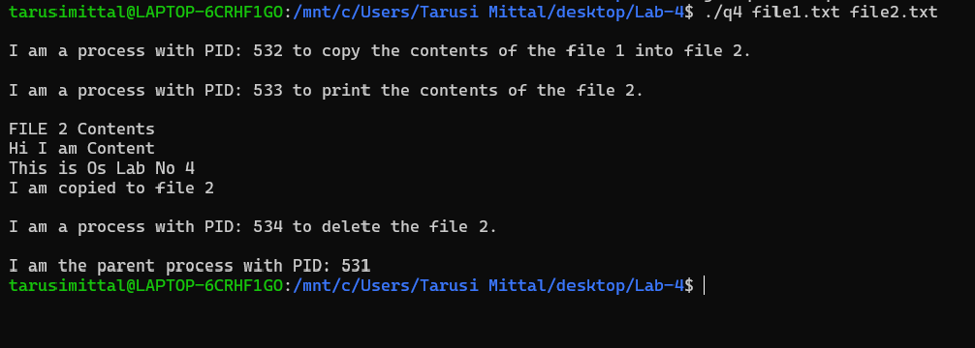

END